41.18: The allowed 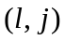 combinations are 